SAFE ROOM  5X7 |  |  |  | SAFE ROOM  6X8 |  |  |  | SAFE ROOM  7X9
Zone | Retail Price | Deposit |  | Zone | Retail Price | Deposit |  | Zone | Retail Price | Deposit
1 | CALL FOR PRICING IN THIS AREA |  |  | 1 | CALL FOR PRICING IN THIS AREA |  |  | 1 | CALL FOR PRICING IN THIS AREA
2 | $5150 | $800 |  | 2 | $5600 | $800 |  | 2 | $6000 | $800
3 | $4850 | $800 |  | 3 | $5350 | $800 |  | 3 | $5750 | $800
4 | $4750 | $800 |  | 4 | $5600 | $800 |  | 4 | $6000 | $800
5 | $4800 | $800 |  | 5 | $5600 | $800 |  | 5 | $6000 | $800
6 | $4850 | $800 |  | 6 | $5350 | $800 |  | 6 | $5750 | $800
7 | $4650 | $800 |  | 7 | $5300 | $800 |  | 7 | $5700 | $800
8 | $4750 | $800 |  | 8 | $5300 | $800 |  | 8 | $5700 | $800
8A | $4750 | $800 |  | 8A | $5300 | $800 |  | 8A | $5700 | $800
9 | $4750 | $800 |  | 9 | $5300 | $800 |  | 9 | $5700 | $800
10 | $4850 | $800 |  | 10 | $5350 | $800 |  | 10 | $5750 | $800
11 | $4950 | $800 |  | 11 | $5500 | $800 |  | 11 | $5900 | $800
12 | CALL FOR PRICING IN THIS AREA |  |  | 12 | CALL FOR PRICING IN THIS AREA |  |  | 12 | CALL FOR PRICING IN THIS AREA

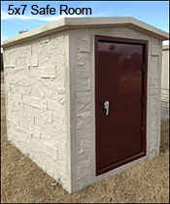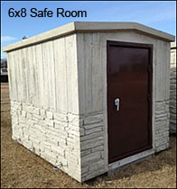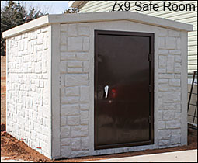
REGULAR SLOPE FRONT SHELTER PRICES  6’X8’ FITS 8-12 PEOPLE |  |  |  | EASY ENTRY SLOPE FRONT SHELTER PRICES  6’X8’ FITS 8-12 PEOPLE
ZONE | RETAIL PRICE | DEPOSIT |  | ZONE | RETAIL PRICE | DEPOSIT
1 | CALL FOR PRICING IN THIS AREA |  |  | 1 | CALL FOR PRICING IN THIS AREA
2 | $3400 | $325 |  | 2 | $3875 | $300
3 | $3275 | $325 |  | 3 | $3775 | $300
4 | $3300 | $325 |  | 4 | $3775 | $300
5 | $3300 | $325 |  | 5 | $3775 | $300
6 | $2975 | $300 |  | 6 | $3475 | $300
7 | $2900 | $300 |  | 7 | $3400 | $300
8 | $2750 | $300 |  | 8 | $3150 | $300
8A | $2750 | $300 |  | 8A | $3150 | $300
9 | $2750 | $300 |  | 9 | $3150 | $300
10 | $2800 | $250 |  | 10 | $3350 | $300
11 | $3150 | $300 |  | 11 | $3650 | $300
12 | CALL FOR PRICING IN THIS AREA |  |  | 12 | CALL FOR PRICING IN THIS AREA

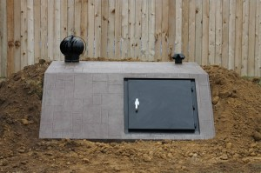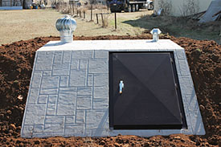

Flat Top 6x8 = $3100 + $3.00/mile from E.C. OK
Suggested Retail = $3600 + dirt haul off

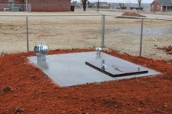
Deposit=$500

Flat Top 6x13 = $5100.00 + $3.00/mile from our lot in E.C. OK
Suggested Retail = $5700.00 + dirt haul off

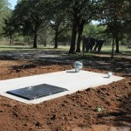
Deposit=$600

For All Types of Area Septic Shelters
**If dirt has to be hauled off there is a fee of $125/load
**If dirt is moved for the customer there will be a fee of $50-$100 depending on how far it is moved
Options Available:
Matching Turbine = $100
Wooden Benches (made out of 2x12s) = $100

Includes:
- ¼” steel doors
- Rust resistant coating
- Vent hole on sliding lid
- Removable steps
- Store away handrail
- Back door release from inside
- Carpeted benches and floor
- Lifetime non-transferrable warranty against leaking and floating
Options:
- Corner safe $75-$125
- Winch door-come along $50-$75
- Color-$50 (Sherwin Williams)
Trip Charge:
- 1 hr. away $150
- 1.5 hrs. away $250
- 2 hrs. away $350
- 3+ hrs. away $450 and up
**$200 minimum if jackhammer used & will vary depending on how long it is used**

In Garage In-Ground Storm Shelter
SIZES | RETAIL PRICE | DEPOSIT
SMALL  3’ X 7’ X 4.5’  6-8 PEOPLE | $3250 | $300
MEDIUM  5’ X 7’ X 5.5’  8-12 PEOPLE | $4149 | $350
JUMBO  5’ X 8’ X 5.5’  12-16 PEOPLE | $4699 | $400
